Assignment 2

Question-1 :

**1 . Importing Required Package**

**Solution :**

import pandas as pd import seaborn as sns import numpy as np

from matplotlib import pyplot as plt

%matplotlib inline

Question-2 :

1. **Loading the Dataset Solution :**

df = pd.read_csv("/content/Churn_Modelling.csv")

df

**Output:**

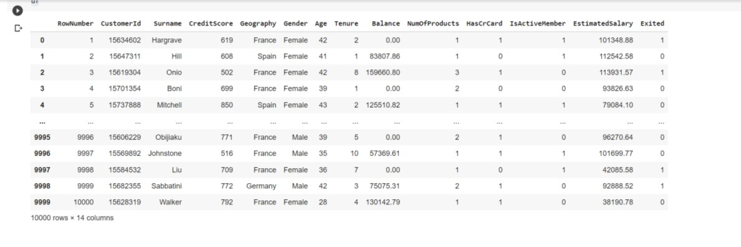

1. **Visualizations** Question-3 :

* 1. **Univariate Analysis**

**Solution:**

sns.displot(df.Tenure)

**Output:**

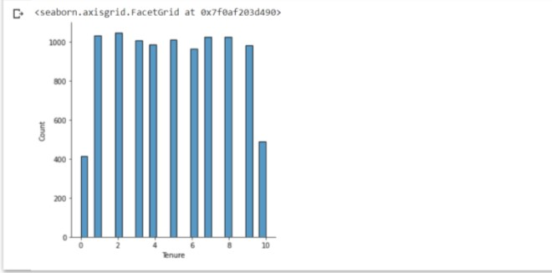

* 1. **Bi-Variate Analysis Solution:**

df.plot.line()

**Output:**

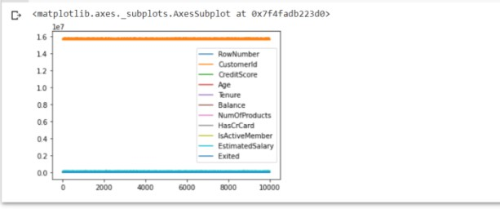

* 1. **Multi - Variate Analysis Solution:**

sns.lmplot("Age","NumOfProducts",df,hue="NumOfProducts", fit_reg=False);

**Output:**

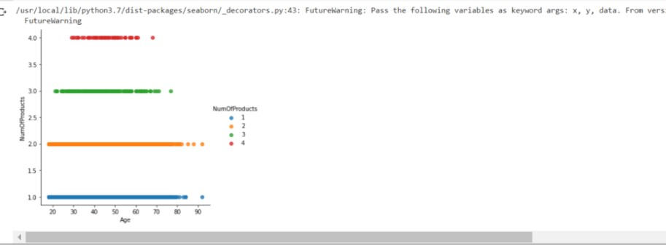

1. **Perform descriptive statistics on the dataset.** Question-4 :

**Solution:**

df.describe()

**Output:**

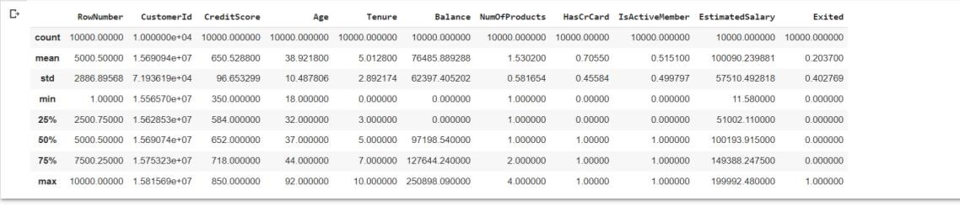

1. **Handle the Missing values.** Question-5 :

**Solution:**

data = pd.read_csv("Churn_Modelling.csv") pd.isnull(data["Gender"])

**Output:**

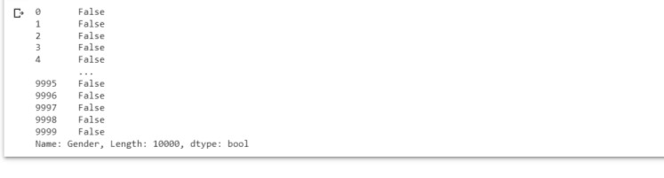

Question-6:

1. **Find the outliers and replace the outliers.** **Solution:**

df["Tenure"] = np.where(df["Tenure"] >10, np.median,df["Tenure"]) df["Tenure"]

**Output:**

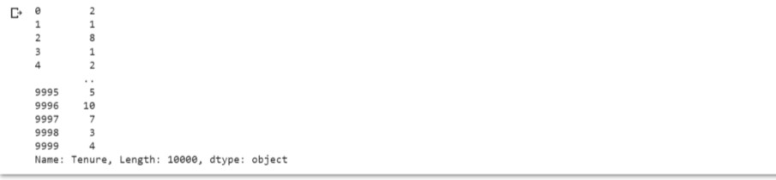

Question-7 :

1. **Check for Categorical columns and perform encoding.**

**Solution:**

pd.get_dummies(df, columns=["Gender", "Age"], prefix=["Age", "Gender"]

).head()

**Output:**

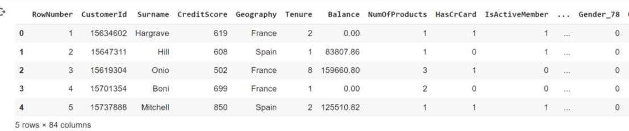

**Output:**

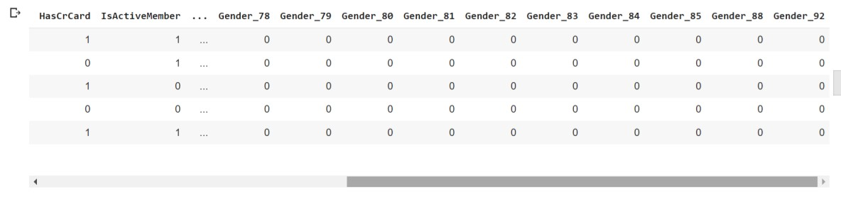

Question-8:

1. **Split the data into dependent and independent variables** 
   1. **Split the data into Independent variables.**

**Solution:**

1. = df.iloc[:, :-2].values print(X)

**Output:**

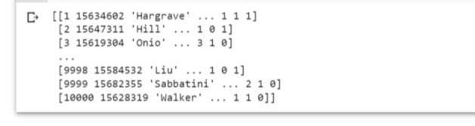

**8.2 Split the data into Dependent variables.**

**Solution:**

1. = df.iloc[:, -1].values print(Y)

**Output:**



Question-9 :

1. **Scale the independent variables Solution:**

import pandas as pd

from sklearn.preprocessing import MinMaxScaler scaler = MinMaxScaler()

df[["RowNumber"]] = scaler.fit_transform(df[["RowNumber"]]) print(df)

**Output:**

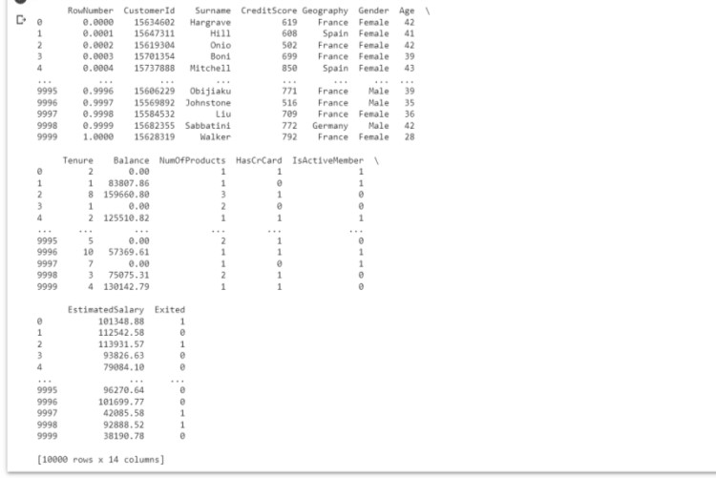

Question-10 :

1. **Split the data into training and testing Solution:**

from sklearn.model_selection import train_test_split train_size=0.8

X = df.drop(columns = ['Tenure']).copy()

y = df['Tenure']

X_train, X_rem, y_train, y_rem = train_test_split(X,y, train_size=0.8) test_size = 0.5

X_valid, X_test, y_valid, y_test = train_test_split(X_rem,y_rem, test_size=0.

5)

print(X_train.shape), print(y_train.shape) print(X_valid.shape), print(y_valid.shape) print(X_test.shape), print(y_test.shape)

**Output:**

